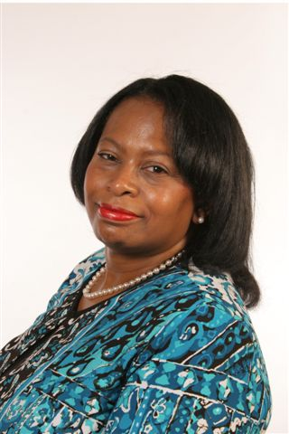
Brenda Stuart-Luke
Brenda is an IRS veteran with 42 years of experience. During her tenure with IRS she has worked in various IRS Business Units such as Human Resources, Criminal Investigation, Collection Division, Taxpayer Service, and Communication. Brenda has been employed in various roles such as Management, Enforce Officer, and her current position is an IRS Stakeholder Liaison in IRS Communication Stakeholder Field Business Operating Unit. She is also the New York Lead for the IRS Multicultural Team, the President of IRS New York Chapter EEO organization, and a standing member of the New York New Jersey Federal Interagency Council. As a Stakeholder Liaison she participates coordinates, and shares IRS key messages through outreach and public speaking. She collaborates and conducts speaking engagements with tax professional organizations, White house leaders, Colleges and Universities, Congressional Offices, Chambers of Commerce, Industry associations, community leaders, Faith based groups, tribal nations, government agencies and others. Brenda is also a Board Member of the South Hampton African American Museum and the Brooklyn Hispanic Chamber of Commerce. Brenda has received recognition and awards from Tax Professional Groups, Political leaders, Minority & non-profit organization, Faith based & Educational groups, Limited English leaders and other for her outstanding community service and outreach.

